**Explanatory note**

●Program name: Battleship

●Classical battleship game created in wpf. It includes 2 game modes such as player vs player and player vs computer.

Artificial intelligence can place ships according to the game rules and shot algorithm makes it a worthy opponent.

●<https://github.com/Unluck/battleship>

●There are 2 members: Semyon Mitrofanov(General logic) and Yuriy Kirillov(UI, Secondary logic)

●Data and Logic:

GameSetting.cs - basic game setting (user name)

Location.cs - constructor for locations of ship

Repository.cs - class for saving all data

Ship.cs - constructor for ship initialization

ComputerLogic.cs - logic for random placement and computer shooting

Events.cs - class for receiving result of the shot

LeaderBoard.cs - logic for download and upload from file

ShipPlacement.cs - logic for manual ship placement for user

●UI:

GameResultWindow - showing result of the game

LeaderboardPage - showing information about the best games

ModeSelectionPage - selection of mode

OnePlayerPage - game mode player vs computer

ShipPlacementPage - ship placement in mode player vs computer

StartingPage - starting page of the game

TwoPlayersPage - game mode player vs player

TwoPlayersShipPlacementPage - ship placement in mode player vs player

●Program interface(next page)

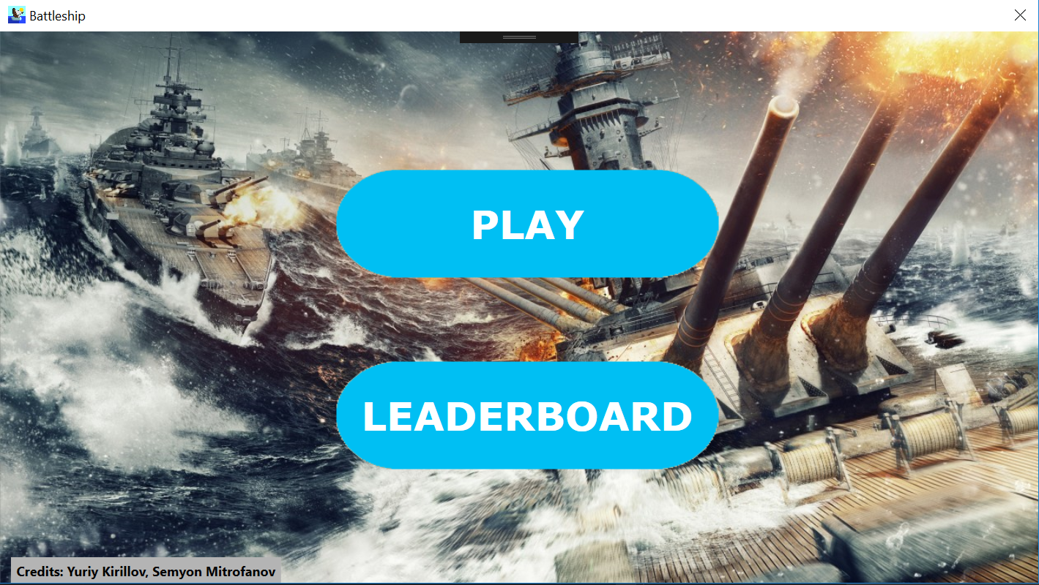

pic 1. Starting page of the program.

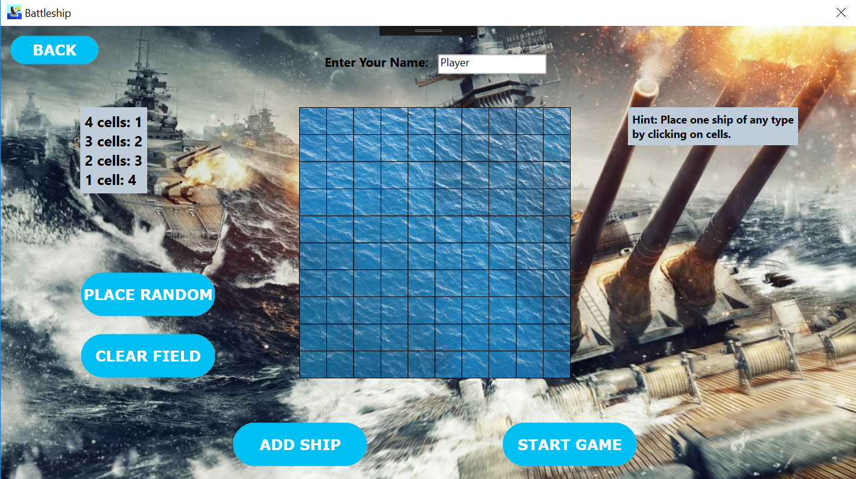

pic 2. Ship placement in mode player vs computer.

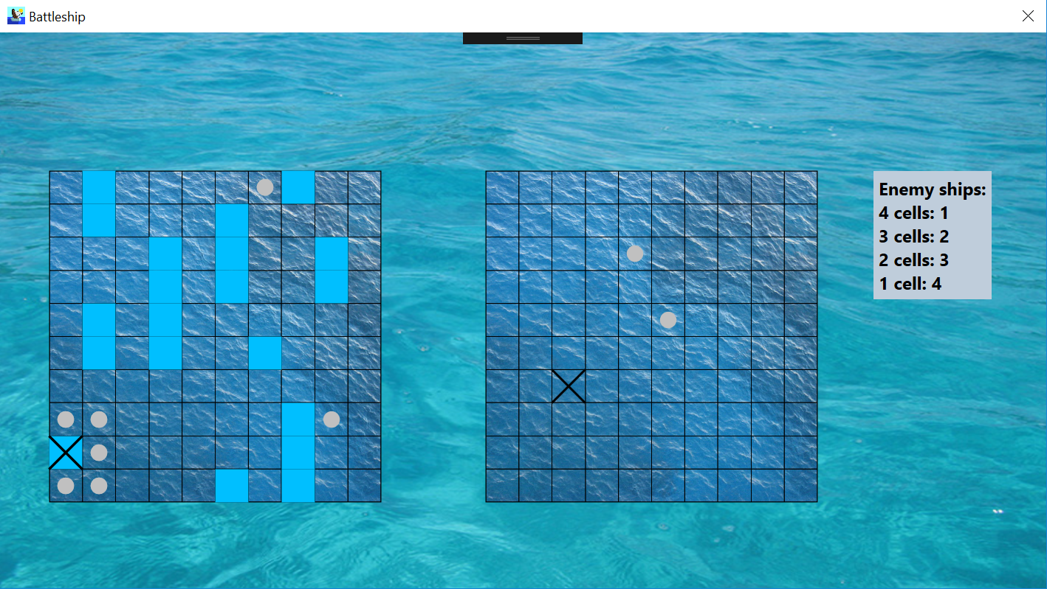

pic 3. Player vs computer gameplay process.

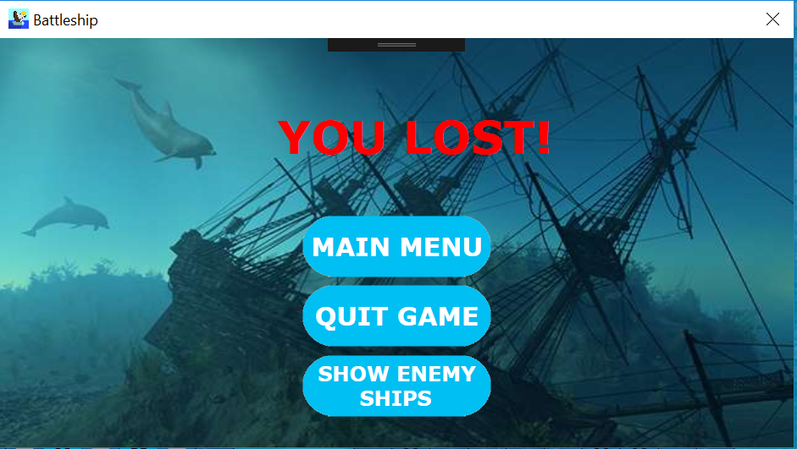

pic 4. Game result window in case of loss.

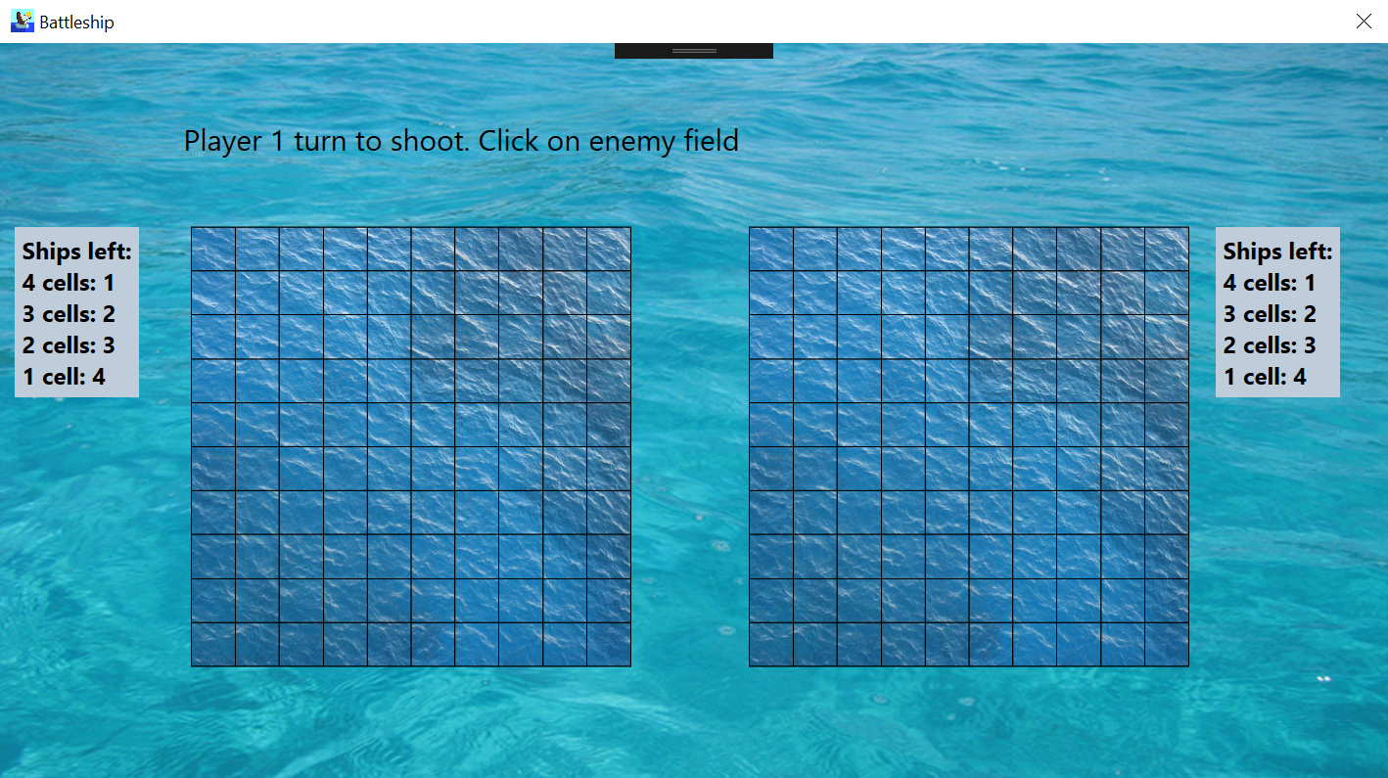

pic 5. Player vs player gameplay process.

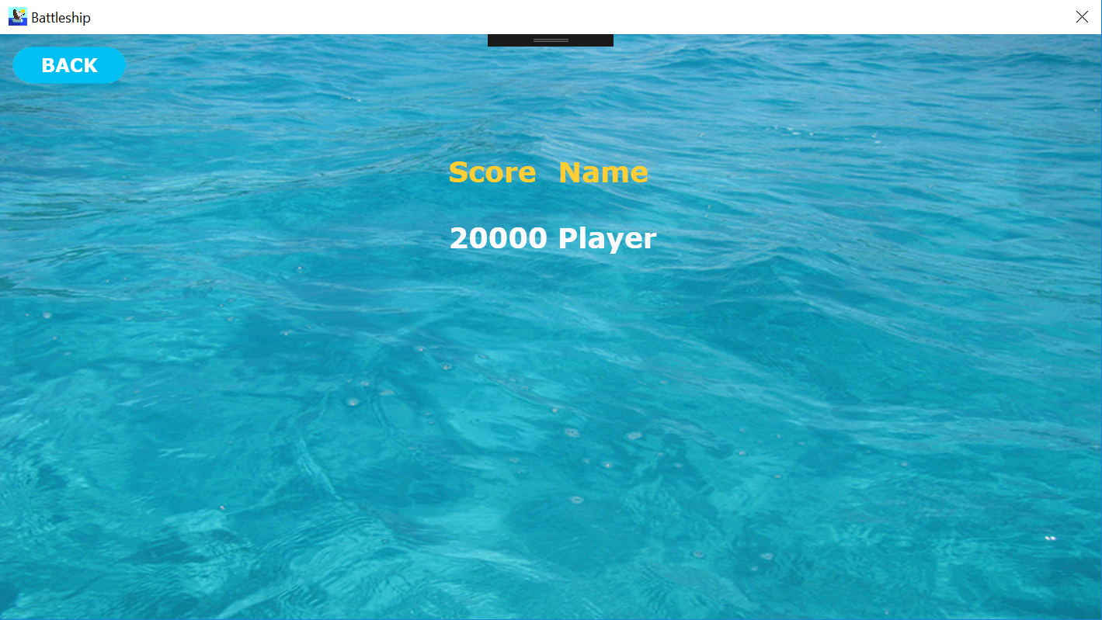

pic 6. Leaderboard window.